The Philosophy Club of Philadelphia
Exploring ideas since 2000 and probably earlier!
amfriedcas@gmail.com albfcc@icloud.com https://www.fried-cas.com/philosophy
Epistemology – a presentation to the Philosophy Club of Philadelphia by Austin Rooney on November 13, 2025, followed by discussion  On November 13, 2025, participants in the Philosophy Club of Philadelphia will be treated to a compelling presentation about Epistemology. That is the study of knowledge and how we come to have it. | 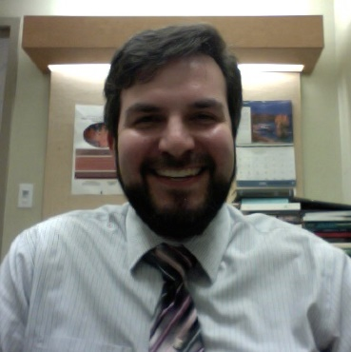
The talk will be given by Prof. Austin Rooney, Lecturer, Philosophy and Religion, Rutgers University-Camden.
A deep understanding of Epistemology is not necessary to benefit from and understand this presentation and discussion. Some issues that will be discussed may include: What is an economical answer to the question: What is knowledge? What are the main sub-topics in the field? Can we know anything absolutely, or only partially? Does modern physics, such as Quantum Physics, affect our judgments about what constitutes knowledge? What are the political dimensions of knowledge. Example: How can we determine whether vaccines work? The above questions are so broad-ranging that we will likely limit questions to the ones that most interest attendees,
This meeting of the Philosophy Club of Philadelphia is open to all who are interested. You may attend in person or via zoom.

Date and Time: | Thursday, November 13, 2025, 7-8:30 Eastern Time.
For those attending in-person: | The meeting will be held in the apartment of Albert and Martha Fried-Cassorla, at the 2101 Cooperative, 21 South 19th Street, Philadelphia, PA 19103, at the corner of Walnut and 21st streets. More specific location information will be given to registrants.
Confirmation: | Send an email with your planned method of attending to  amfriedcas@gmail.com. Or call Albert at 215 219 4772.
Preparation: | Suggested readings and watching will be sent later. Meanwhile, this Wikipedia article lays out essentials of the field:  https://en.wikipedia.org/wiki/Epistemology
Zoom link | https://us02web.zoom.us/j/87644333154

